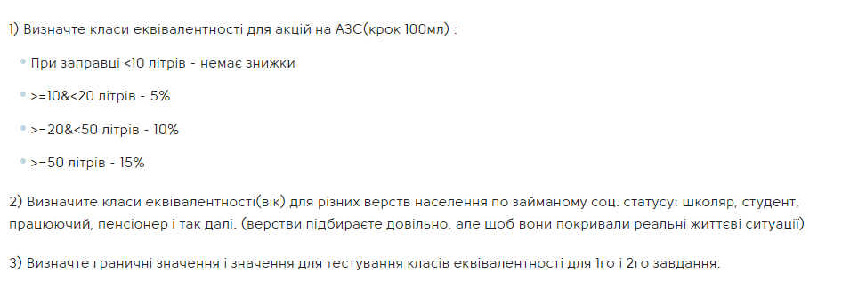

1. between 0 to 9,9 - 0%

2.between 10 to 19,9 - 5%

3.between 20 to 49,9 - 10%

4. between 50 to +infinity - 15%

**4 equivalence partitions. All of them are valid/positive.**

Boundary values:

-0.1,0,0.1 - 5 - 9,8, 9.9;

10 - 15.5 - 19.8, 19,9;

20 - 35.2 - 49.8, 49.9;

50 - 1040.

2.

1. between -infinity to 4 - negative/invalid

2. between 5 to 18 - schoolkid - positive/valid

3.between 19 to 25 - student - positive/valid

4. between 26 to 65 - worker - positive/valid

5.between 66 to 500 - pensioner - positive/valid

6. between 501 to +infinity - invalid/negative.

**6 equivalence partitions.**

Boundary values :

-5 - 0 - 3, 4;

5 - 12 - 17, 18,19;

22 - 24, 25;

26 - 38 - 64, 65;

66 - 82 - 499, 500;

501 - 668 .